Name: Michael Campos

CSE222: Computer Architecture & Organization

**Final Exam 2020S(A)**

(May 2020, SCCC)

**Part I (60)**

1. (10 pts) Answer Questions
2. What is multiplexer, what is decoder?

**A multiplexer has only one output that will become 2N possible inputs. Inputs are selected using N select inputs. A decoder has N input and 2N outputs, it selects one of the 2N possible outputs.**

1. List 3 notations to describe logical circuits functions

**Three notations to describe logical circuits are truth tables, boolean expressions, and logic diagrams.**

1. What is big-endian, what is little-endian byte order? Given the following hexadecimal number **0xABCDEF12**, indicate how this number is saved as big-endian and little-endian in the following memory block:

Big-endian byte order:

|  |  |  |  |
| --- | --- | --- | --- |
| 0x1000 | 0x1001 | 0x1002 | 0x1003 |
| AB | CD | EF | 12 |

Little-endian

|  |  |  |  |
| --- | --- | --- | --- |
| 0x1000 | 0x1001 | 0x1002 | 0x1003 |
| 12 | EF | CD | AB |

1. Give a brief description of “fetch-decode-execute” cycle

**The PC (Program Counter) retrieves a program’s instruction from its memory and then copies to the MDR (Memory Data Register) and then to the CIR (Current Instruction Register). The PC is incremented by 1 so it points at the next instruction. The instruction that was copied is decoded and executes. Then the process is repeated.**

1. (14 pts) Simplify the following Boolean equations using Boolean algebra theorems. Write out the procedure to get the final result. Draw logical diagrams after simplification (using logical gates):
2. F = (+ B) (A + B + D)

**F = B * !D**

1. F = C (B D ) + B + A C

**F = !A*B*!D + !B*C**

1. (16 pts) Below is a Boolean equation in Sigma format:

F(A,B,C,D) = ∑ (0, 1, 2, 3, 6, 7, 8, 9, 10, 11, 14)

1. Simplify the equation using K-map; Draw a logical diagram, using logic gates to implement the function

!A*!B + !A*C + C*!D + A*!B

= !B + C(!A + !D)

LOGICAL DIAGRAM IN PICTURE BELOW

1. Draw logical diagram, using 4:1 multiplexer(s) + 2:1 multiplexer to implement the function

PICTURE BELOW

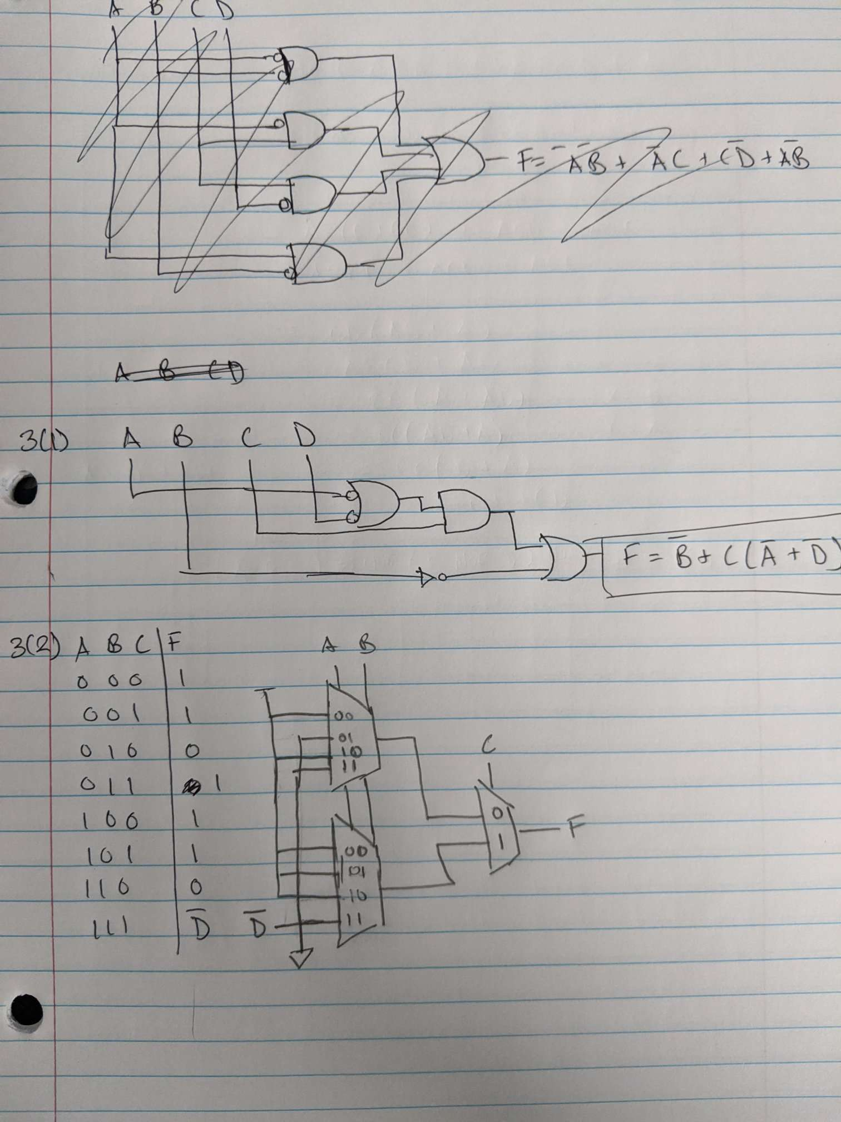

1. (20 pts) Design a logic circuit which has 4 inputs and 1 output. The circuit will check if a 4-bit binary number is close enough to number 5, or 10, or 15. If yes, set output to 1, otherwise set output to 0. “**close enough to 5 or 10 or 15**” is defined as following:

**| number – 5 | <=1** or **| number-10 | <=1** or **| number-15 | <=1**

1. Specify the function in a truth table
2. Describe the function in Boolean expression in SOP form.
3. Build the circuit using logical gates. If need, simplify the Boolean equation in (b) first, then draw logical diagram
4. Build the circuit using 4:1 multiplexer(s), draw this logical diagram

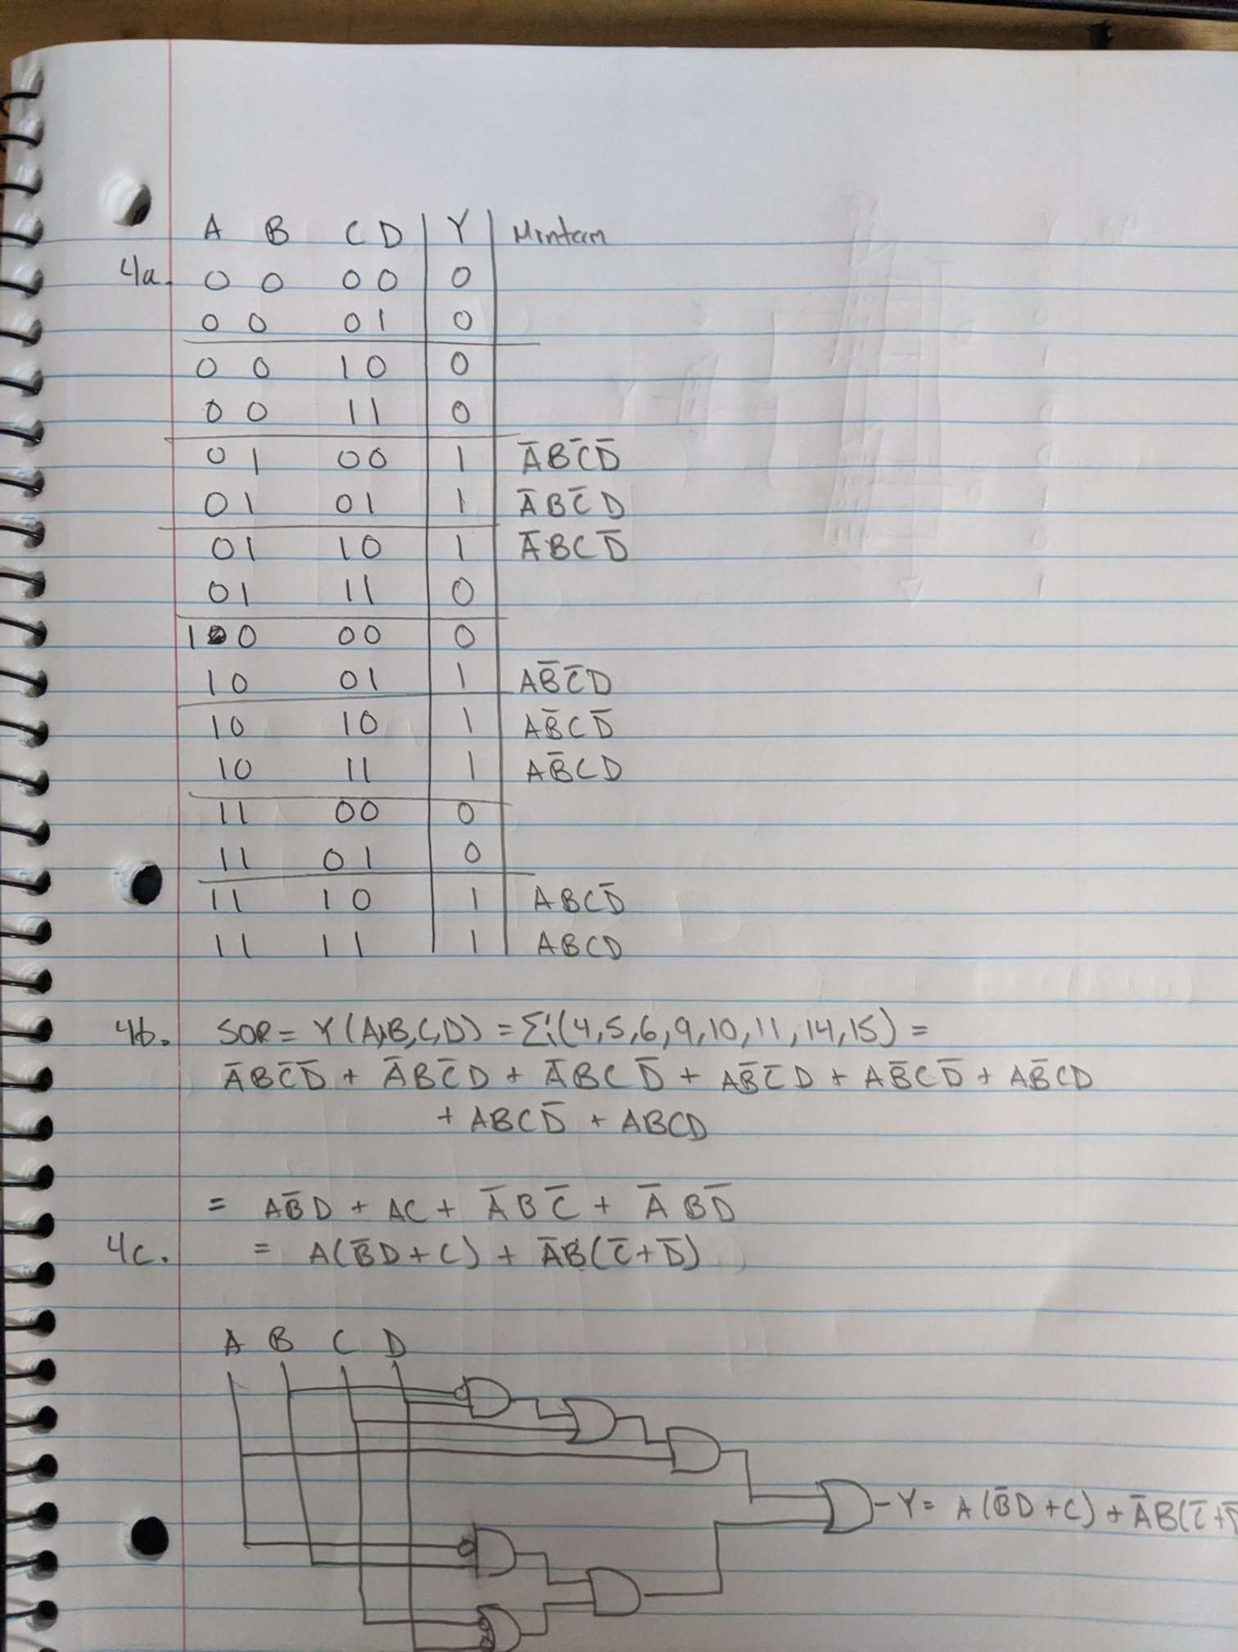

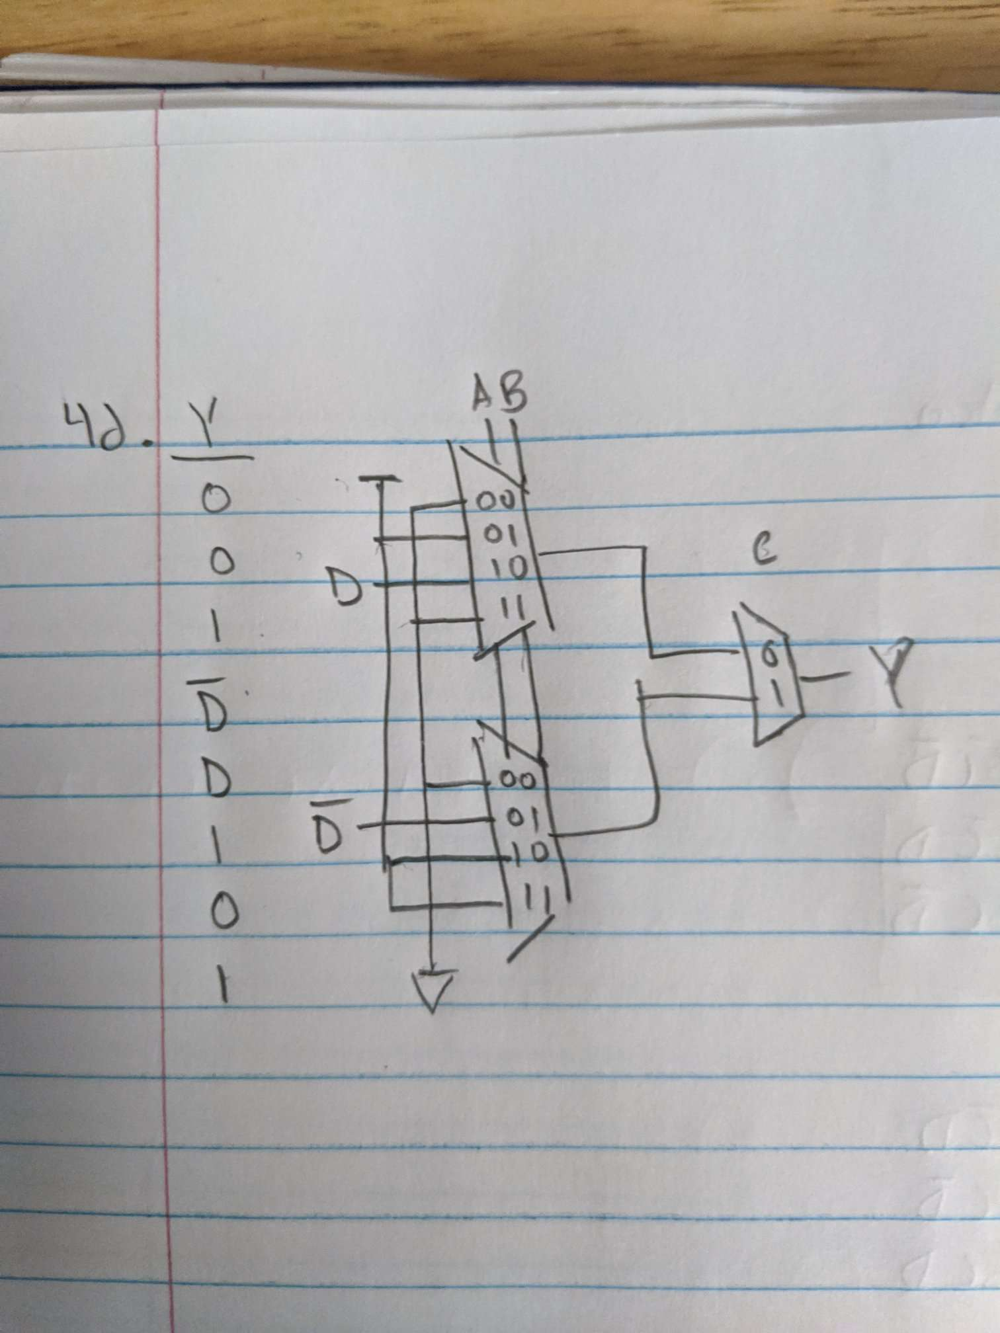

**Part II: MIPS programming**

1. (**15 pts**) Write MIPS program:
2. Define a word variable **x**
3. Prompt user to enter an integer number from console, save this number to **x**
4. Calculate 5 * x, display result
5. Use another method to calculate 5 *x, display result
6. (25 pts) For the following pseudo code, write MIPS program to implement the same function:

**// define an array of size 10**

**int [] array = new int [10];**

**// initialize array with random numbers**

**for (int i=0; i<10; i++) {**

**array[i] = random number in range [0, 100];**

**}**

**// call the function**

**int [] result = getInfoFromArray(array, 10);**

**// display return result:**

**Display “the maximum element <number> is found at location <location>”**

**// this method will check array and find the maximum elements in array**

**// return this number and its location in array where this number is found**

**int [] getInfoFromArray(int [] array, int arraySize) {**

**int idx = 0;**

**for (int i=0; i<arraySize; i++)**

**if (array[i] > array[idx]) {**

**idx = i;**

**}**

**return new int[2] { array[idx], idx };**

**}**